ASSESSMENT TOOL 2: Scenario-Based Research Assessment
COURSE NAME: | ARTIFICIAL INTELLIGENCE AND EXPERT SYSTEMS
COURSE CODE: | MLA0102
COURSE OUTCOME COVERED
CO1: Apply search algorithms and heuristic techniques to solve state-space search and optimization problems. (BTL 3)
Assessment Tool Weightage: 45 %
Total Marks: 50 Time: 60 Mins
No. of Questions: 5
Annexure A

Scenario-Based Research Assessment
Code of Conduct:
I Deepika V (192325008) certify that this submission is my original work and that I have adhered to the guidelines specified for this assessment.
I understand that any violation of academic integrity rules will result in disciplinary action.
Signature of the student: Deepika V
Criterion | Weightage | Marks Obtained
Identification of Latest AI Application | 10%
Problem Analysis and Domain Understanding | 15%
AI Technologies and Working Mechanism | 20%
Research Quality and Literature Review | 10%
Real-World Implementation and Case Analysis | 10%
Impact, Challenges, and Future Scope | 15%
Originality and Critical Thinking | 10%
Organization, Presentation, and Documentation | 10%
Total | 100%
Signature of the Faculty Total Marks Awarded

Structure of the Report:
S.No | Report Component | Student Deliverable / Guiding Question
1 | Title of AI Application | Provide the name of the latest AI application selected and the corresponding AI domain.
2 | Domain Selection | Identify the application domain (Healthcare / Finance / Retail / Autonomous Vehicles / Robotics / Manufacturing).
3 | Introduction and Background | Describe the AI application and provide an overview of its purpose and importance.
4 | Problem Identification | Explain the real-world problem or challenge addressed by this AI application.
5 | Need for AI Solution | Analyse why AI is required and how it improves traditional approaches.
6 | AI Technologies Used | Identify the AI techniques involved (Machine Learning, Deep Learning, NLP, Computer Vision, Generative AI, Robotics, etc.).
7 | Working Mechanism | Explain how the AI system works, including input data, processing methods, decision-making, and output generation.
8 | Data Sources and Processing | Describe the type of data used and how the data is processed for intelligent decision-making.
9 | Real-World Implementation | Identify organizations, industries, or real-world scenarios where this AI application is currently implemented.
10 | Impact and Benefits | Evaluate the improvements achieved through the AI application in terms of efficiency, accuracy, cost, user experience, or automation.
11 | Challenges and Limitations | Discuss technical, ethical, privacy, security, and deployment challenges associated with the application.
12 | Future Scope and Emerging Trends | Explain possible enhancements, future developments, and research opportunities in this AI application.
13 | Conclusion | Summarize the significance of the AI application and its contribution to solving real-world problems.
14 | References | Provide research papers, technical articles, industry reports, and reliable sources referred for the study.

AI-Based Intelligent Traffic Management System
(Smart Cities Domain)
1. Title of AI Application
AI-Based Intelligent Traffic Management System
AI Domain: Smart Cities (Urban Artificial Intelligence / Intelligent Transportation Systems - ITS)
2. Domain Selection
Application Domain: Smart Cities (Urban Infrastructure and Public Services)
The selected AI application belongs to the Smart Cities domain. It is widely deployed by municipal corporations and traffic police departments to monitor road networks, control traffic signals in real time, and manage vehicle flow across busy urban junctions. By combining Artificial Intelligence, Computer Vision, IoT sensors, and Big Data Analytics, the system reduces congestion, shortens travel time, lowers pollution, and improves overall road safety.
3. Introduction and Background
Description of the AI Application
AI-Based Intelligent Traffic Management is a smart urban system that continuously observes road and junction conditions using cameras, inductive loop sensors, and GPS data from connected vehicles. Instead of relying on fixed-time traffic signals, the AI system analyses live traffic density, vehicle speed, and queue length to dynamically adjust signal timings and traffic flow across the city.
Signals are adjusted only when required, congestion hotspots are identified early, and emergency vehicles can be given priority passage, reducing delays and improving the efficiency of the entire urban transport network.
Purpose
The main purpose of this application is to:
- Reduce traffic congestion at busy junctions and corridors.
- Minimise average commuter travel and waiting time.
- Improve road safety and reduce accident rates.
- Prioritise emergency vehicles such as ambulances and fire trucks.
- Lower vehicular emissions caused by idling in traffic.
- Support data-driven urban traffic planning.
Importance
Traditional traffic control relies on fixed-timer signals or manual control by traffic police, which cannot adapt to real-time changes in vehicle density, accidents, or weather conditions. AI enables adaptive, condition-based traffic control by continuously analysing live road conditions, ensuring that signal timing and rerouting decisions reflect actual demand rather than a fixed schedule.
4. Problem Identification
Real-World Problem or Challenge Addressed
Rapid urbanisation and rising vehicle ownership place enormous strain on city road networks. Unmanaged traffic can lead to:
- Frequent traffic congestion and long commute times
- Increased fuel consumption and air pollution
- Higher accident rates at poorly managed junctions
- Delayed emergency response due to blocked roads
- Economic losses from lost productivity
- Reduced quality of life for city residents
AI-Based Intelligent Traffic Management addresses these challenges by continuously sensing road conditions and recommending or automatically executing timely traffic-control actions.
5. Need for AI Solution
Analysis
Traditional traffic management approaches have several limitations:
- Fixed-timer signals cannot adapt to changing traffic volumes.
- Manual traffic police control is labour-intensive and inconsistent.
- Static systems fail to respond to accidents or sudden congestion.
- Poor coordination between signals across a city corridor.
AI improves traffic management by:
- Continuously monitoring live traffic conditions.
- Predicting congestion before it builds up.
- Dynamically optimising signal timings across junctions.
- Coordinating a 'green corridor' for emergency vehicles.
- Supporting data-driven decisions for urban planners.
6. AI Technologies Used
The system combines several AI technologies.
Computer Vision
Detects and classifies vehicles, pedestrians, and congestion levels from live camera feeds.
Machine Learning
Learns historical traffic patterns to forecast congestion at specific times and locations.
Deep Learning
Uses convolutional neural networks (CNNs) for accurate vehicle detection and number-plate recognition.
Reinforcement Learning
Continuously optimises signal-timing policies based on real-time traffic outcomes.
Internet of Things (IoT)
Connects sensors, cameras, and traffic signals for real-time data exchange.
Big Data Analytics
Processes large volumes of traffic and mobility data collected across the city.
Cloud Computing
Stores city-wide traffic data and runs large-scale AI models centrally.
Edge AI
Processes video and sensor data locally at intersections for faster response.
7. Working Mechanism
Step 1: Input Data
Sensors and cameras installed across the city collect:
- Live video feeds from traffic cameras
- Vehicle counts from inductive loop sensors
- GPS and speed data from connected vehicles
- Weather and visibility data
- Emergency vehicle location signals
Step 2: Data Processing
Collected data is:
- Cleaned and filtered
- Converted into vehicle counts and congestion indices
- Normalised across different sensor types
- Time-stamped and geo-tagged
Step 3: AI Model Analysis
The machine learning and deep learning models compare current traffic readings with historical patterns to identify congestion build-up, detect incidents, and forecast short-term traffic flow at each junction.
Step 4: Decision Making
The AI system determines:
- Optimal signal-phase durations for each junction
- Alternate route recommendations for commuters
- Priority green corridors for emergency vehicles
- Congestion severity and incident alerts
Step 5: Output Generation
The system generates:
- Adaptive traffic signal commands
- Real-time congestion alerts to commuter apps
- Live dashboards for city traffic control centres
- Incident and accident notifications to authorities
8. Data Sources and Processing
Structured Data
- Vehicle counts from loop sensors
- GPS coordinates and vehicle speed logs
- Historical signal-timing records
- Weather data
- Public transit schedules
Unstructured Data
- Live camera video feeds
- Images for number-plate recognition
- Citizen-reported traffic incidents
- Social media traffic updates
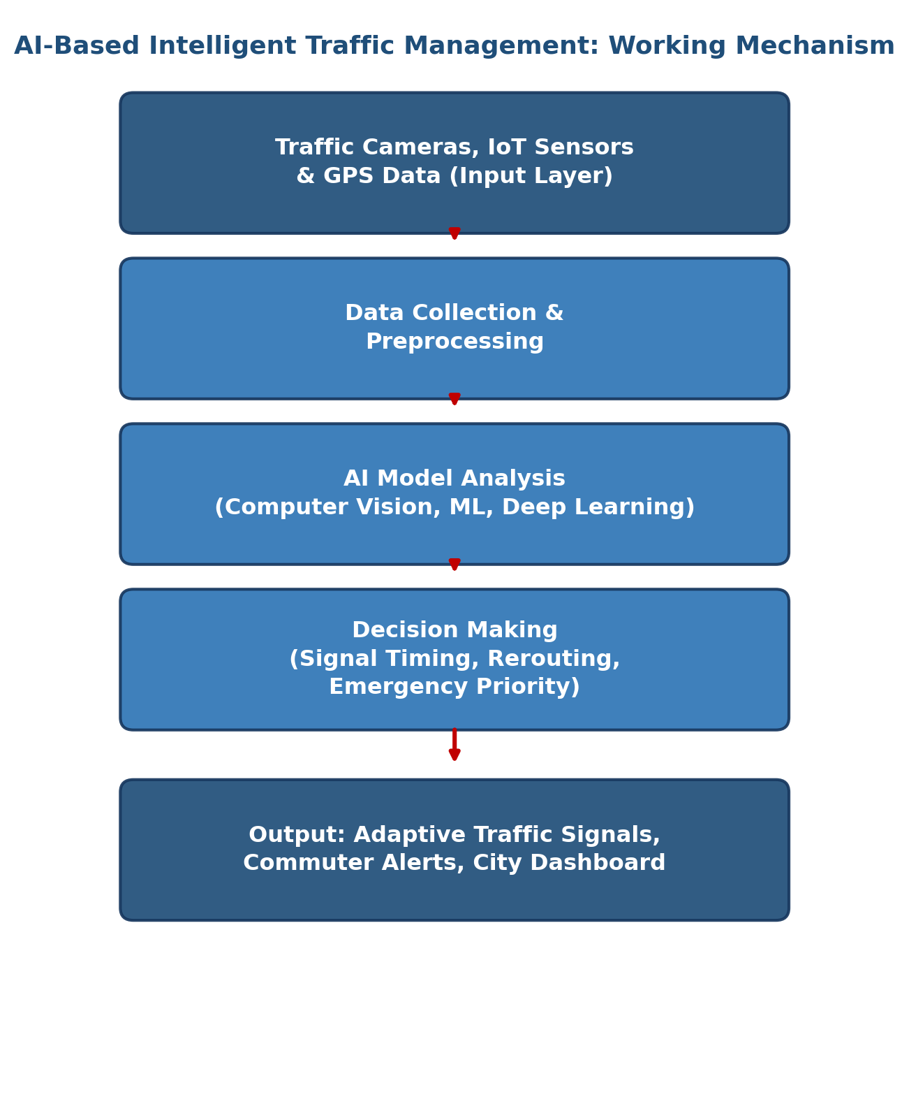
Figure: Working mechanism of the AI-Based Intelligent Traffic Management System
9. Real-World Implementation
Several cities and organisations use AI-based intelligent traffic management.
Alibaba Cloud – City Brain (Hangzhou, China)
Uses AI to analyse live camera feeds across the city and dynamically adjust signal timings, reportedly cutting travel time at monitored intersections.
Siemens Sitraffic
Provides AI-enabled adaptive traffic-signal control systems used in multiple European cities.
Surtrac (Pittsburgh, USA)
An AI-based adaptive signal system developed with Carnegie Mellon University that adjusts signals in real time based on live traffic.
Los Angeles ATSAC
The Automated Traffic Surveillance and Control system coordinates signals across thousands of intersections.
Singapore Land Transport Authority
Uses AI and sensor networks for intelligent transport system planning and congestion pricing.
IBM Intelligent Transportation Solutions
Applies AI and analytics for traffic prediction and smart-city mobility planning.
Other Applications
AI-based traffic management concepts are also extended to:
- Smart parking guidance systems
- Public transit scheduling optimisation
- Toll and congestion-pricing systems
- Pedestrian safety and crossing management
10. Impact and Benefits
Reduced Congestion
Adaptive signals ease bottlenecks at high-traffic junctions.
Shorter Commute Times
Dynamic routing and signal optimisation cut average travel time.
Lower Emissions
Less idling in traffic reduces fuel consumption and vehicle emissions.
Improved Road Safety
Early incident detection helps prevent secondary accidents.
Faster Emergency Response
Green-corridor prioritisation speeds up ambulance and fire-service transit.
Data-Driven Urban Planning
City planners gain accurate insights into mobility patterns for future infrastructure decisions.
11. Challenges and Limitations
Technical Challenges
- Camera performance degrades in poor lighting or bad weather
- Large volumes of continuous video data to process
- Model accuracy depends on sensor and camera quality
- Integration with older, non-digital traffic infrastructure
Ethical Challenges
- Public concern over surveillance and citizen privacy
- Potential bias in vehicle or number-plate recognition models
Security Challenges
- Cybersecurity threats to connected traffic-signal networks
- Risk of unauthorised access to city control systems
Deployment Challenges
- High cost of citywide sensor and camera installation
- Need for skilled AI and traffic-engineering professionals
- Continuous model retraining as traffic patterns evolve
- Complex coordination across multiple city departments
12. Future Scope and Emerging Trends
Future developments include:
Connected and Autonomous Vehicles (V2X)
Vehicles communicate directly with traffic infrastructure for safer, more efficient flow.
Digital Twins of Cities
Virtual replicas of road networks for real-time simulation and planning.
Explainable AI (XAI)
Provides transparent reasoning behind automated traffic-control decisions.
5G-Enabled Traffic Systems
Enables ultra-low-latency data exchange between vehicles and infrastructure.
Predictive Urban Mobility Analytics
Forecasts long-term mobility demand to guide infrastructure investment.
Integration with Smart Public Transit
Combines traffic AI with bus and metro scheduling for seamless city mobility.
13. Conclusion
AI-Based Intelligent Traffic Management is transforming urban mobility by enabling real-time monitoring of road networks and adaptive control of traffic signals. Through Computer Vision, Machine Learning, IoT, and Big Data Analytics, cities can reduce congestion, shorten commute times, lower emissions, and improve road safety. Although challenges such as installation cost, data privacy, and cybersecurity remain, ongoing advancements in connected vehicles, 5G, and explainable AI are making intelligent traffic systems a core component of smart-city infrastructure. This application significantly contributes to safer, more efficient, and more sustainable urban transportation.
14. References
- Zhao, L., et al. (2019). Intelligent Traffic Signal Control Using Deep Reinforcement Learning. IEEE Transactions on Intelligent Transportation Systems.
- Alibaba Cloud – City Brain: AI for Urban Traffic Management, Hangzhou.
- Siemens Mobility – Sitraffic Adaptive Traffic Control Solutions.
- Carnegie Mellon University – Surtrac Adaptive Traffic Signal System, Pittsburgh.
- Los Angeles Department of Transportation – ATSAC Traffic Control System.
- Singapore Land Transport Authority – Intelligent Transport Systems Report.
- IBM – AI and Analytics for Smart Transportation.
- IEEE Xplore Digital Library – Research Papers on AI in Smart Traffic Management.
- Springer – Artificial Intelligence Applications in Smart Cities.

